# Assignment 4.3

Name : CH.BHAVYA

Hall.no : 2403A51109

Batch : 06

Task Description#1

● Zero-shot: Prompt AI to write a function that checks whether a given year is a leap  
year.

PROMPT:

write a python function to check whether give year is leap year or not

CODE:

Task Description#2  
● One-shot: Give one input-output example to guide AI in writing a function that  
converts centimeters to inches

Prompt:

write a python program to convert centimeters t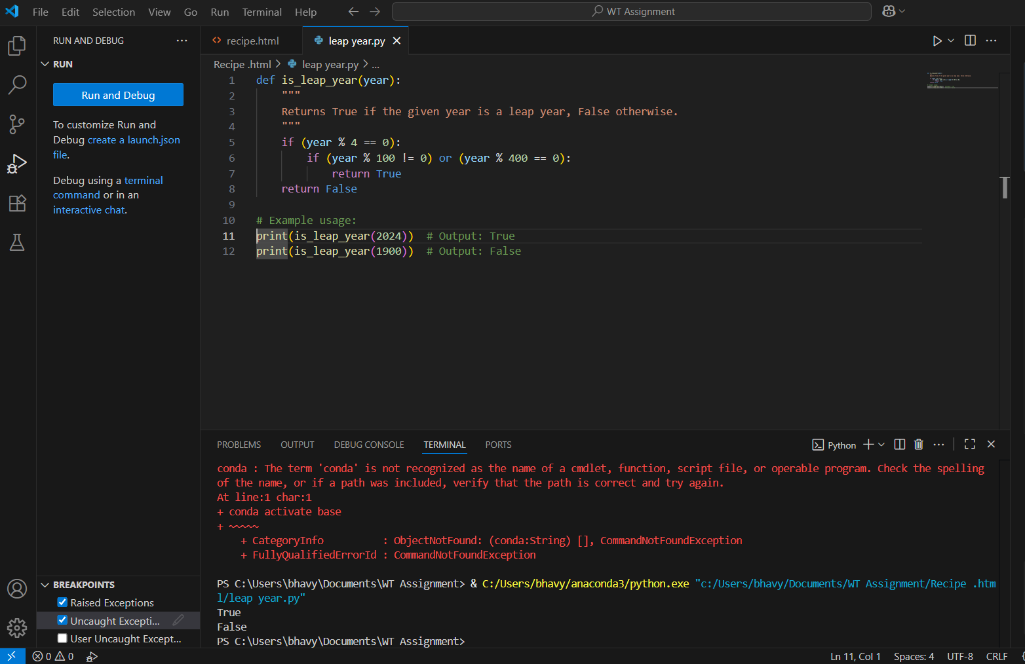o inches and test cases

CODE and OUTPUT:

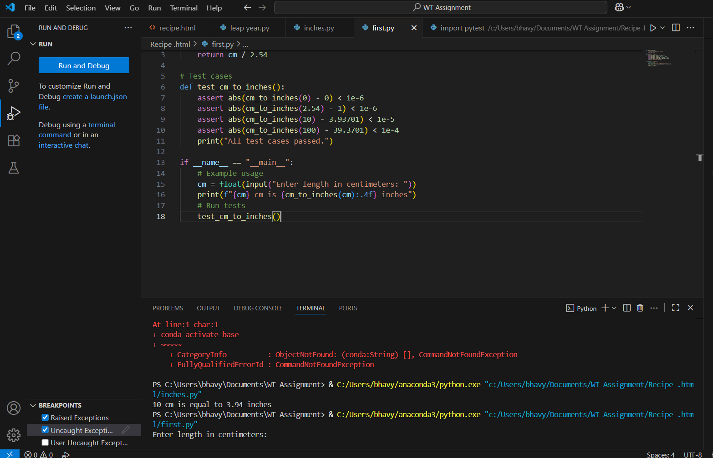

Task Description#3  
● Few-shot: Provide 2–3 examples to generate a function that formats full names as  
“Last, First”.

PROMPT: Write a python to generate a function that formats full names as“Last name, First name”. with some examples.

CODE and OUTPUT: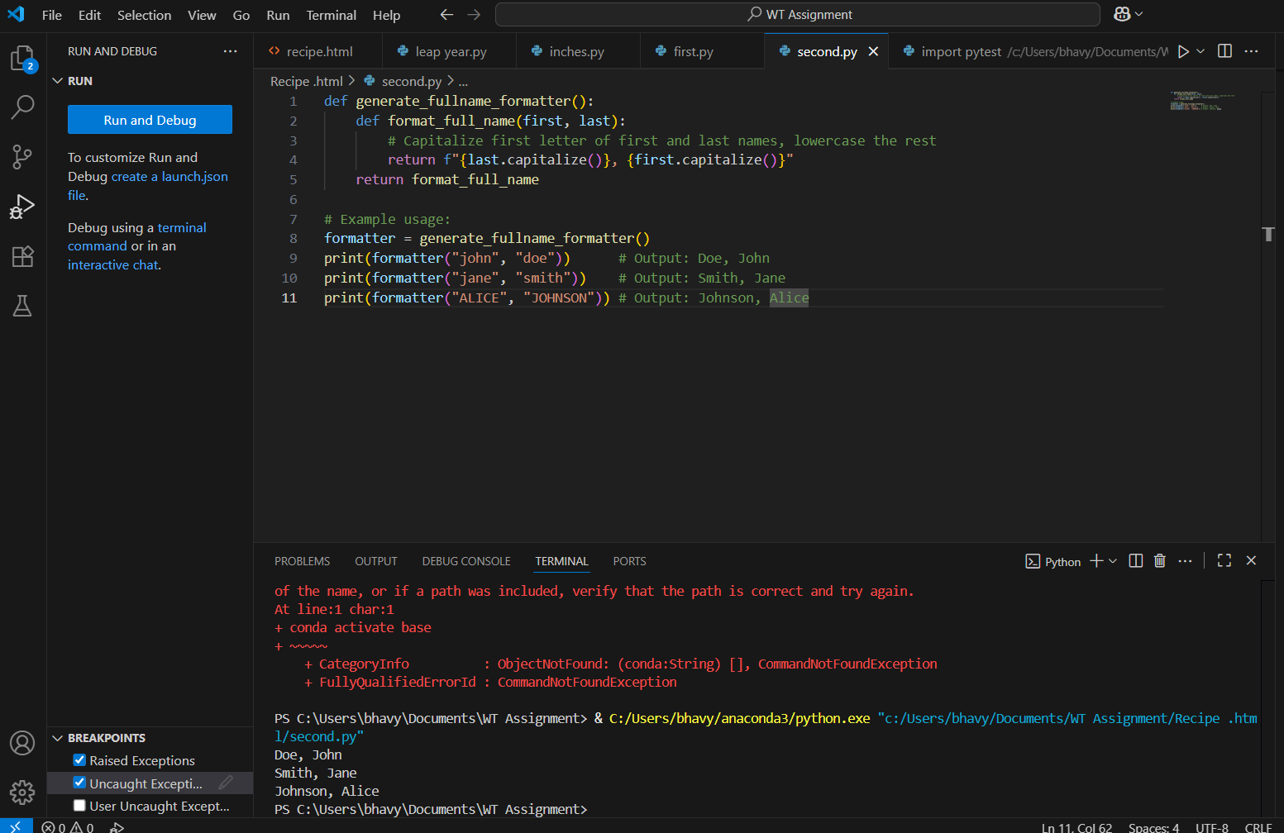

Task Description#4  
● Compare zero-shot and few-shot prompts for writing a function that counts the  
number of vowels in a string.

PROMPT: write a python function that counts number of vowels ina string with some examples

CODE and OUTPUT:

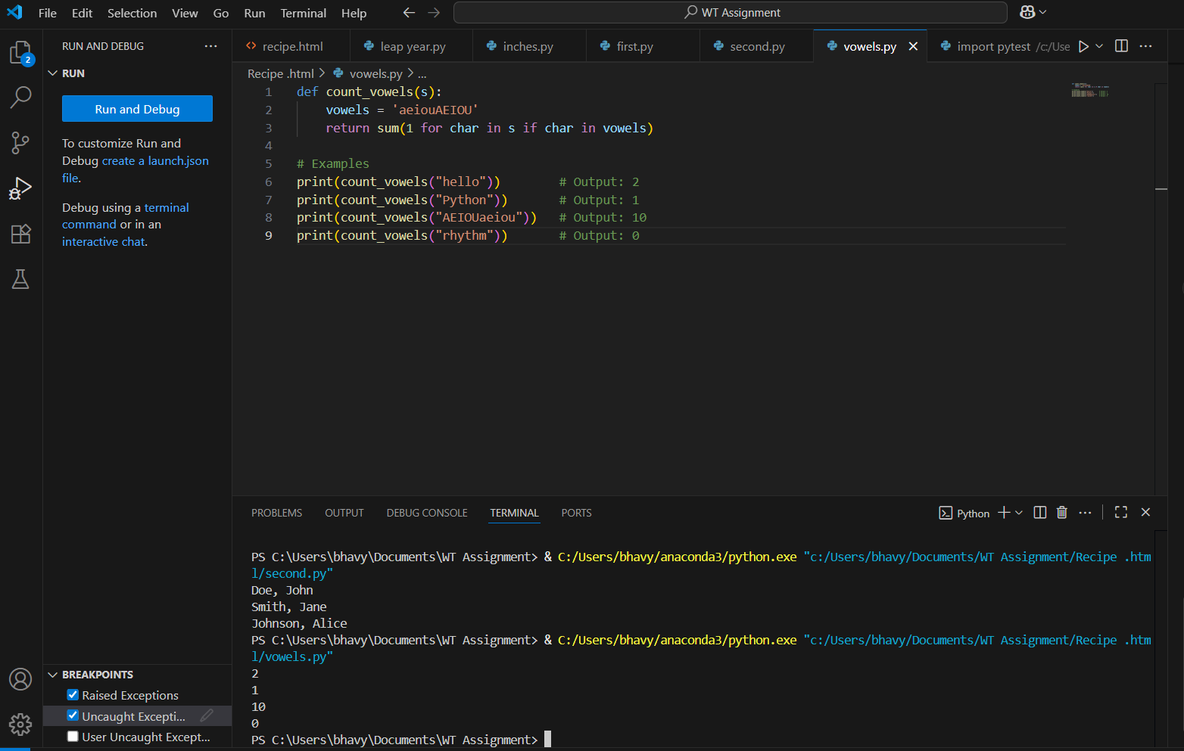

Task Description#5  
● Use few-shot prompting to generate a function that reads a .txt file and returns the number of lines

PROMPT: write a python function to generate a function that reada .txt file and returns the number lines

CODE and OUTPUT:

